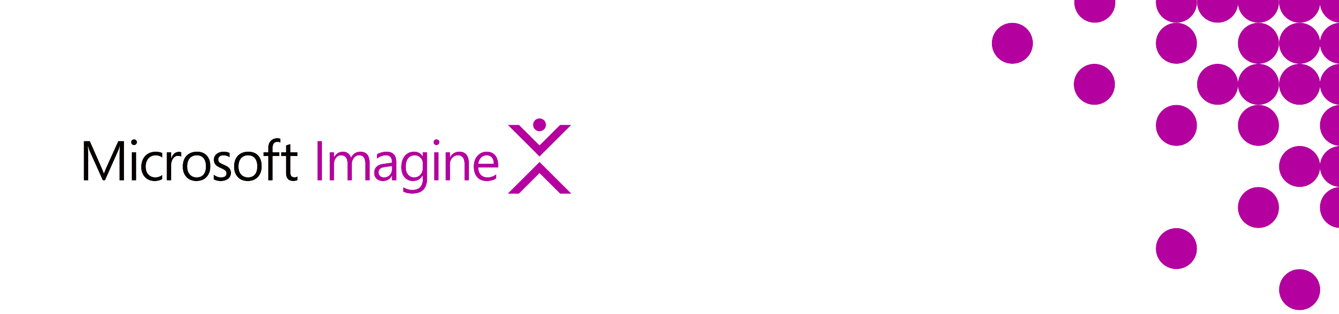**Cognitive Services and Bots**

Cloud Computing and Big Data are merging into a trend that utilizes both remote computing and large-scale computation: Cognitive Computing. Massive data sets of the world around us are compiled every second (images, videos, audio, and text) and we need to quickly and accurately sift through that data to reach meaningful conclusions. Microsoft Cognitive Services implement cognitive computing and employ machine learning to provide actionable insights using vision, speech, language, knowledge, and search APIs.

Bots interact with your users naturally wherever they are – from your website or app to Cortana, Skype, Office 365 mail, Slack, Facebook Messenger, Skype for Business and more. Cognitive Services enable your bot to see, hear, interpret and interact in more human ways. Azure Bot Service provides a foundation for building custom bots to allow humans to interact with machines in productive ways.

**Cognitive Services**

Effective cognitive computing requires easy-to-use service endpoints consumable by apps with images, audio, and other media and data that needs to be processed by sophisticated cognitive systems that return straightforward and usable results. Let your students get their hands on cognitive algorithms quickly using Microsoft’s Cognitive Services APIs. There are many entry points into the exploration of cognitive computing.

**Image Processing**

The Computer Vision API identifies people and objects with a reported level of confidence. Individuals are identified, what they look like, what they are wearing, their age and demographic, what they are doing, and if they are part of a group. Objects are identified, such as buildings, houses, natural features such as rivers or mountains, or household objects such as dinner rolls or flowers, then placed in a context such as a city, a plate of bread, or a train station. Tags denote the notable aspects of the image, the most prominent or identifiable images that help determine what the image is “about”.

[Learn More](https://docs.microsoft.com/en-us/azure/cognitive-services/computer-vision/home)

[Get Started](https://docs.microsoft.com/en-us/azure/cognitive-services/computer-vision/tutorials/pythontutorial)

**Face Detection**

The Face API imbues your apps with the ability to identify a person using an image of their face. The API compares two images containing faces and reports on how well they match up. This is accomplished using proportions of the head, hair color, and facial landmarks such as eyes, eyebrows, nose, and lips.

[Learn More](https://docs.microsoft.com/en-us/azure/cognitive-services/face/overview)

[Get Started](https://docs.microsoft.com/en-us/azure/cognitive-services/face/tutorials/faceapiinjavaforandroidtutorial)

**Emotion Detection**

The detection of human emotion based upon facial expression allows systems to understand how people may be feeling. The Emotion API is invoked using a simple URL call which uploads your image containing one or more faces. Cognitive Services processes the image and returns emotion indices for each face such as anger, contempt, fear, happiness, and surprise.

[Learn More](https://docs.microsoft.com/en-us/azure/cognitive-services/emotion/home)

[Get Started](https://docs.microsoft.com/en-us/azure/cognitive-services/emotion/tutorials/pythontutorial)

**Speech Recognition**

The Custom Speech API provides a powerful speech recognition system exposing acoustic models and language models for customization. Identifying and verifying a particular speaker is a next step in speech cognition and is provided by the Speaker Recognition API.

[Learn More](https://docs.microsoft.com/en-us/azure/cognitive-services/custom-speech-service/cognitive-services-custom-speech-home)

[Get Started](https://docs.microsoft.com/en-us/azure/cognitive-services/custom-speech-service/cognitive-services-custom-speech-get-started)

**Language**

While speech recognition determines what a person is saying, language understanding extracts deeper meaning such as topic, sentiment, and desire. Build custom language models to interpret what a person wants using the Language Understanding Intelligent Service (LUIS). Learn to map human utterances in natural language to entities and intents to know what object or person someone is talking about, how they feel about it, and what they would like to see happen with it.

[Learn More](https://docs.microsoft.com/en-us/azure/cognitive-services/luis/home)

[Get Started](https://docs.microsoft.com/en-us/azure/cognitive-services/luis/luis-nodejs-tutorial-build-bot-framework-sample)

**Knowledge**

Explore the ability to search complex data using natural language queries using the Knowledge Exploration Server (KES). Define your own data schema and populate it with your data. Construct query grammars used to parse language requests and extract and filter data, then host your query engine as a service online. Employ natural language understanding to evaluate queries, offer intelligent recommendations, query auto-completion, and semantic search.

[Learn More](https://docs.microsoft.com/en-us/azure/cognitive-services/kes/overview)

[Get Started](https://docs.microsoft.com/en-us/azure/cognitive-services/kes/gettingstarted)

**Search**

Although not strictly a cognitive function, the search of web pages, images, news, and video is often a necessary part of cognitive projects. The Bing Web Search API provides a search engine which consumes search query terms and produces JSON search responses.

[Learn More](https://docs.microsoft.com/en-us/azure/cognitive-services/bing-web-search/search-the-web)

[Get Started](https://docs.microsoft.com/en-us/azure/cognitive-services/bing-web-search/csharp-ranking-tutorial)

**Building Bots**

A bot is an app that users interact with in a conversational way. Bot conversations can range from a basic guided dialog with pre-defined responses to a sophisticated interactive experience that leverages cognitive computing to determine user desires and sentiments.

**Bot Framework**

Building a bot requires a development toolkit and a testing environment. Get started with the Bot Framework, a platform for building, testing, and deploying bots. It includes a Bot Builder SDK with support for .NET, Node.js, and REST. Bot Builder conversations can use simple text or rich cards that contain text, images, and action buttons. Manage and deploy your bot with the Bot Framework portal. The portal provides a central repository for your bots and a way to deploy your bots to a web page.

[Learn More](https://docs.microsoft.com/en-us/bot-framework/azure/azure-bot-service-overview)

[Get Started](https://docs.microsoft.com/en-us/bot-framework/bot-builder-overview-getstarted)

**Azure Bot Service**

Build bots quickly using Azure Bot Service, an online tool for bot development built upon the Bot Framework. Choose from a range of templates including a basic interaction, highly structed forms facilitating particular conversations such as the ordering of a sandwich, natural language understanding to determine user intent, proactive alerts to notify users of events, to an FAQ template to answer users’ most common questions.

Build bots in your browser without the need for a text editor or source control, or choose the continuous integration option and use your own source code control such as GitHub, BitBucket, or Visual Studio. After developing and testing your bot, deploy it to pre-configured channels such as Skype or Web Chat, as well as Bing, Cortana, Facebook Messenger, Kik, and Slack.

Azure Bot Service is an implementation of the Bot Framework using Azure Functions, which allows your bot to run in serverless, scalable containers.

[Learn More](https://docs.microsoft.com/en-us/bot-framework/azure/azure-bot-service-overview)

[Get Started](https://docs.microsoft.com/en-us/bot-framework/azure/azure-bot-service-template-basic)